**VISVESVARAYA TECHNOLOGICAL UNIVERSITY**

**“JnanaSangama”, Belgaum -590014, Karnataka.**



**LAB REPORT**

**on**

**Object Oriented Java Programming (23CS3PCOOJ)**

***Submitted by***

**Chethana.C (1BM23CS077)**

***in partial fulfillment for the award of the degree of***

**BACHELOR OF ENGINEERING**

***in***

**COMPUTER SCIENCE AND ENGINEERING**



**B.M.S. COLLEGE OF ENGINEERING**

**(Autonomous Institution under VTU)**

**BENGALURU-560019**

**Sep-2024 to Jan-2025**

**B.M.S. College of Engineering,**

**Bull Temple Road, Bangalore 560019**

(Affiliated To Visvesvaraya Technological University, Belgaum)

**Department of Computer Science and Engineering**



**CERTIFICATE**

This is to certify that the Lab work entitled “Object Oriented Java Programming (23CS3PCOOJ)” carried out by **Chethana.C(1BM23CS077),** who is bonafide student of **B.M.S. College of Engineering.** It is in partial fulfilment for the award of **Bachelor of Engineering in Computer Science and Engineering** of the Visvesvaraya Technological University, Belgaum. The Lab report has been approved as it satisfies the academic requirements in respect of an Object Oriented Java Programming (23CS3PCOOJ) work prescribed for the said degree.

|  |  |
| --- | --- |
| Geetha N  Assistant Professor  Department of CSE, BMSCE | Prof. Swathi Sridharan  Professor & HOD  Department of CSE, BMSCE |

**Index**

|  |  |  |  |
| --- | --- | --- | --- |
| **Sl.**  **No.** | **Date** | **Experiment Title** | **Page No.** |
| 1 | 01.10.2024 | Implementing Quadratic Equation |  |
| 2 |  | Develop a Java program to create a class Student with members usn, name, an array credits and an array marks. Include methods to accept and display details and a method to calculate SGPA of a student. |  |
| 3 | 15.10.24 | Create a class Book which contains four members: name, author, price, num_pages. Include a constructor to set the values for the members. Include methods to set and get the details of the objects. Include a toString( ) method that could display the complete details of the book. Develop a Java program to create n book objects |  |
| 4 | 22.10.2024 | Develop a Java program to create an abstract class named Shape that contains two integers and an empty method named printArea(). Provide three classes named Rectangle, Triangle and Circle such that each one of the classes extends the class Shape. Each one of the classes contain only the method printArea() that prints the area of the given shape. |  |
| 5 |  | Develop a Java program to create a class Bank that maintains two kinds of account for its customers, one called savings account and the other current account. The savings account provides compound interest and withdrawal facilities but no cheque book facility. The current account provides cheque book facility but no interest. Current account holders should also maintain a minimum balance and if the balance falls below this level, a service charge is imposed.  Create a class Account that stores customer name, account number and type of account. From this derive the classes Cur-acct and Sav-acct to make them more specific to their requirements. Include the necessary methods in order to achieve the following tasks:  a) Accept deposit from customer and update the balance.  b) Display the balance.  c) Compute and deposit interest  d) Permit withdrawal and update the balance  Check for the minimum balance, impose penalty if necessary and update the balance. |  |
| 6 | 12.11.2024 | Create a package CIE which has two classes- Student and Internals. The class Personal has members like usn, name, sem. The class internals has an array that stores the internal marks scored in five courses of the current semester of the student. Create another package SEE which has the class External which is a derived class of Student. This class has an array that stores the SEE marks scored in five courses of the current semester of the student. Import the two packages in a file that declares the final marks of n students in all five courses. |  |
| 7 | 19.11.2024 | We have created an interface named Polygon. It includes a default method getPerimeter() and an abstract method getArea ().  We can calculate the perimeter of all polygons in the same manner so we  implemented the body of get Perimeter() in Polygon.  Now, all polygons that implement Polygon can use getPerimeter () to calculate perimeter.  However, the rule for calculating the area is different for different polygons.  Hence, getArea() is included without implementation.  Any class that implements Polygon must provide an implementation of getArea () |  |
| 8 | 26.11.2024 | Write a program that demonstrates handling of exceptions in inheritance tree. Create a base class called "Father" and derived class called "Son" which extends the base class. In Father class, implement a constructor which takes the age and throws the exception WrongAge() when the input age<0. In Son class, implement a constructor that uses both father and son's age and throws an exception if son's age is >=father's age. |  |
| 9 | 03.12.2024 | Write a program which creates two threads, one thread displaying "BMS College of Engineering" once every ten seconds and another displaying "CSE" once every two seconds |  |
| 10 | 03.12.2024 | Write a program that creates a user interface to perform integer divisions. The user enters two numbers in the text fields, Num1 and Num2. The division of Num1 and Num2 is displayed in the Result field when the Divide button is clicked. If Num1 or Num2 were not an integer, the program would throw a NumberFormatException. If Num2 were Zero, the program would throw an Arithmetic Exception Display the exception in a message dialog box |  |

Github Link:

**https://github.com/Chethana-0711/OOJ-LAB-FINAL**

**Program 1**

Implement Quadratic Equation

Algorithm:

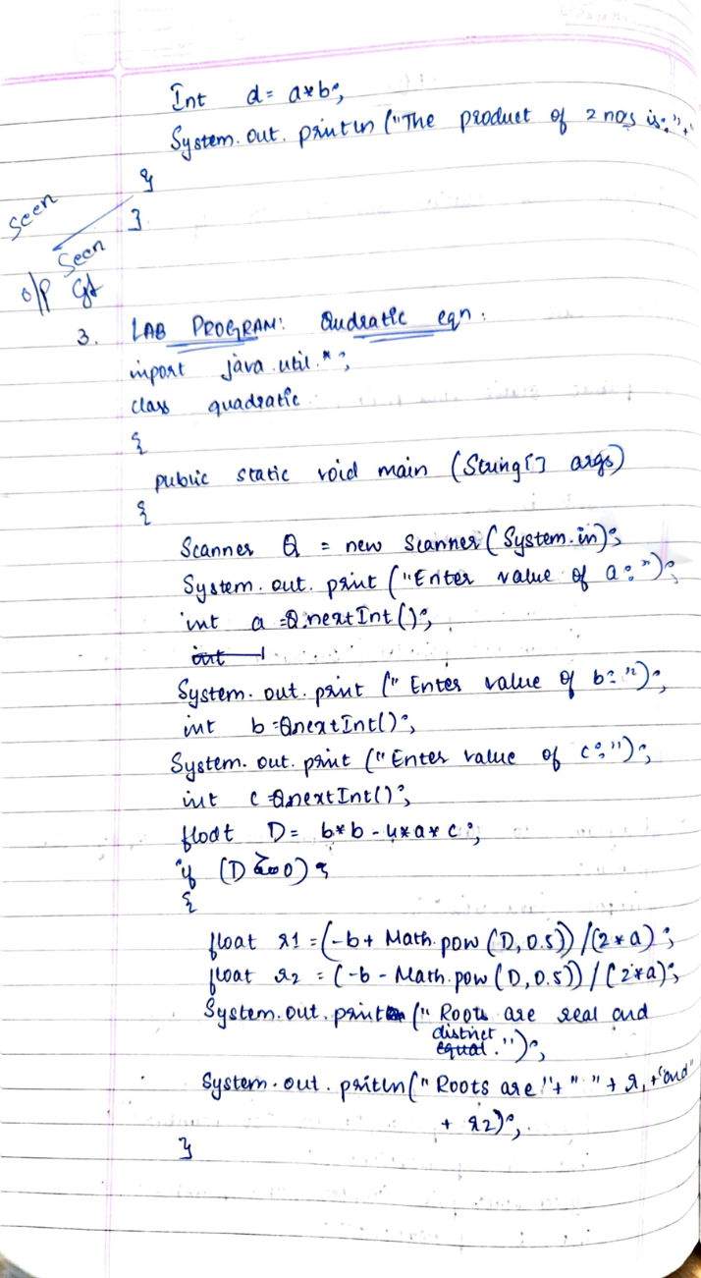 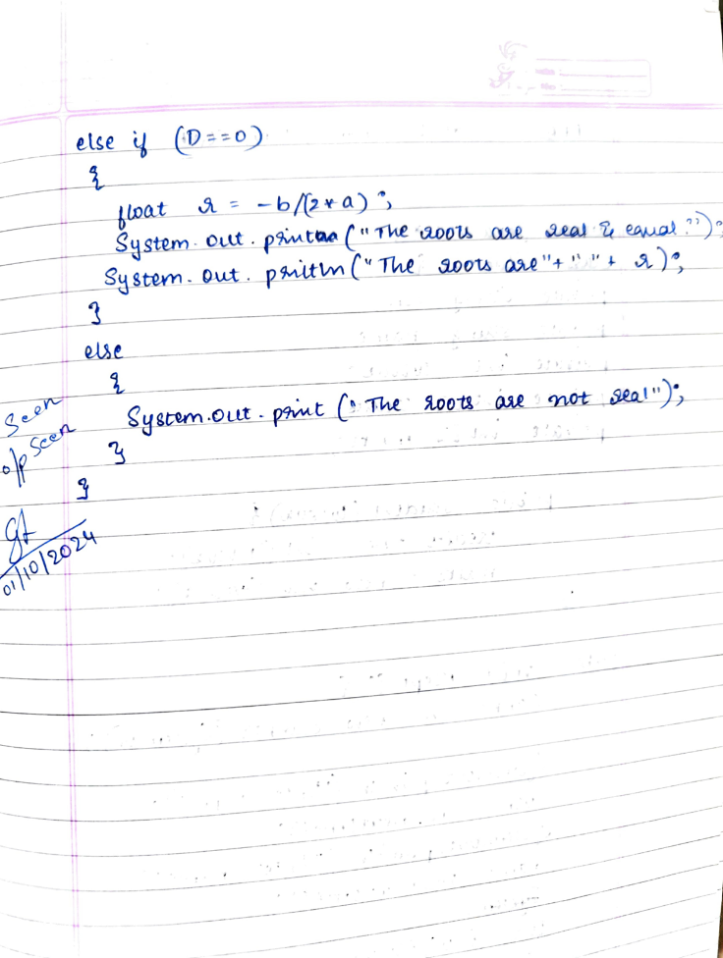

Code:

import java.util.*;

class Quadratic {

public static void main(String[] args) {

Scanner Q = new Scanner(System.in);

System.out.println("CHETHANA.C (1BM23CS077)");

System.out.print("Enter value of a: ");

int a = Q.nextInt();

System.out.print("Enter value of b: ");

int b = Q.nextInt();

System.out.print("Enter value of c: ");

int c = Q.nextInt();

float D= b * b - 4 * a * c;

if(D>0) {

double r1 = (-b + Math.sqrt(D)) / (2 * a);

double r2 = (-b - Math.sqrt(D)) / (2 * a);

System.out.println("the roots are real and distinct");

System.out.println("The roots are = " + r1 + " and " + r2);

}

else if (D == 0) {

double r = -b / (2 * a);

System.out.println("the roots are real and equal");

System.out.println("The roots are "+ r);

}

else {

System.out.println("There are no real solutions.");

}

}

}

Output:

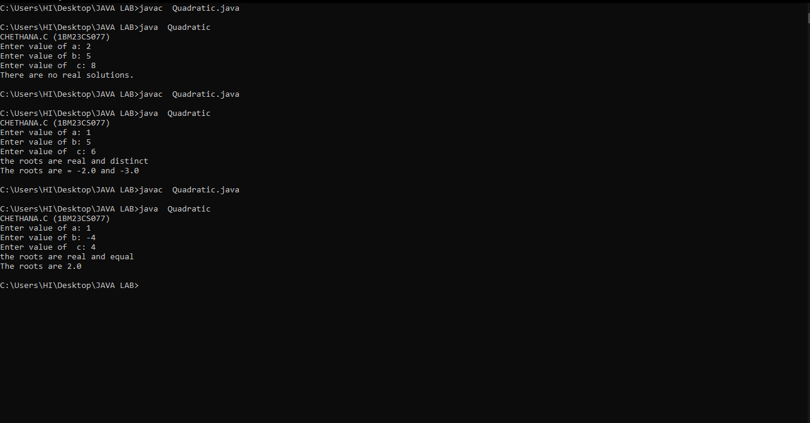

**Program 2**

Develop a Java program to create a class Student with members usn, name, an array credits and an array marks. Include methods to accept and display details and a method to calculate SGPA of a student.

Algorithm:

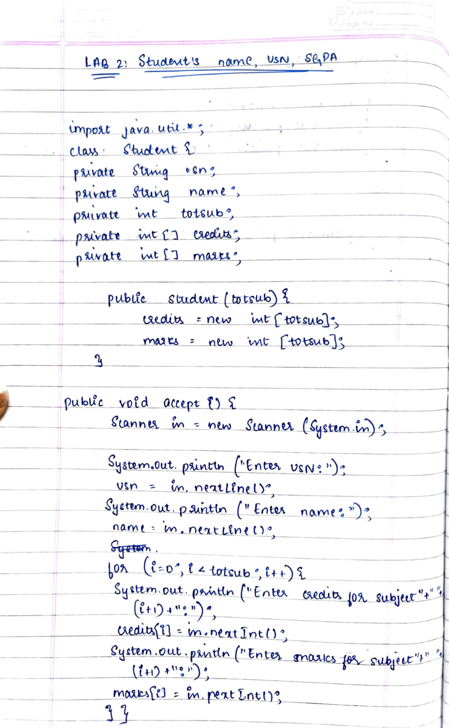 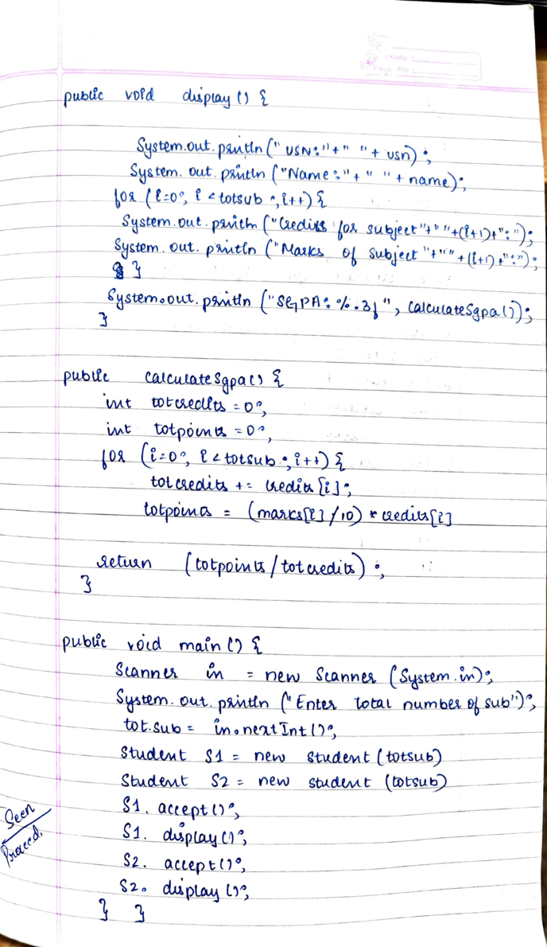

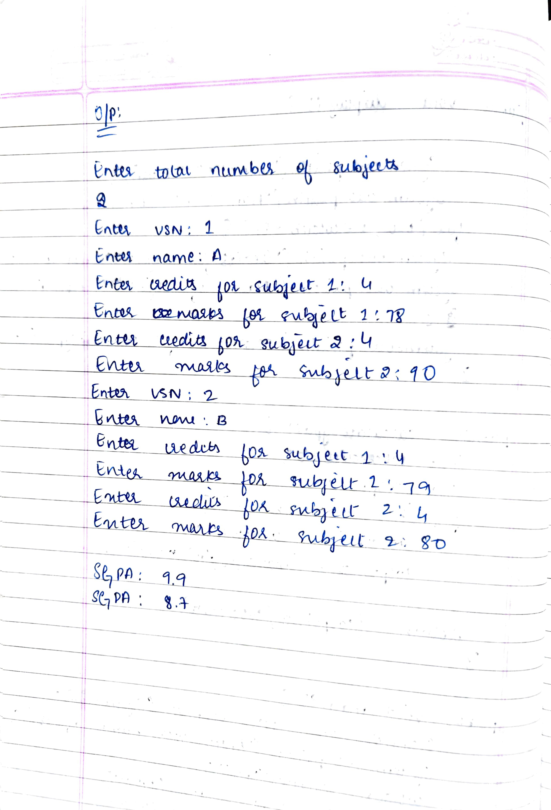

Code:

import java.util.*;

class Student {

String usn;

String name;

int totsub;

int[] credits;

int[] marks;

public Student(int totsub) {

this.totsub = totsub;

credits = new int[totsub];

marks = new int[totsub];

}

public void accept() {

Scanner in = new Scanner(System.in);

System.out.println("Enter USN:");

usn = in.nextLine();

System.out.println("Enter Name:");

name = in.nextLine();

for (int i = 0; i < totsub; i++) {

System.out.println("Enter credits for subject " + (i + 1) + ":");

credits[i] = in.nextInt();

System.out.println("Enter marks for subject " + (i + 1) + ":");

marks[i] = in.nextInt();

}

}

public void display() {

System.out.println("\nStudent Details:");

System.out.println("USN: " + usn);

System.out.println("NAME: " + name);

for (int i = 0; i < totsub; i++) {

System.out.println("Subject " + (i + 1) + " -> Credits: " + credits[i] + ", Marks: " + marks[i]);

}

System.out.printf("SGPA: %.2f\n", calculateSGPA());

}

public double calculateSGPA() {

double totcredits = 0;

double totpoints = 0;

for (int i = 0; i < totsub; i++) {

totcredits += credits[i];

totpoints += marks[i] * credits[i];

}

return totpoints / totcredits;

}

public static void main(String[] args) {

System.out.println("CHETHANA.C (1BM23CS077)

Scanner inn = new Scanner(System.in);

System.out.println("Enter total number of subjects:");

int totsub = inn.nextInt();

Student S1 = new Student(totsub);

S1.accept();

S1.display();

Student S2 = new Student(totsub);

S2.accept();

S2.display();

}

}

Output:

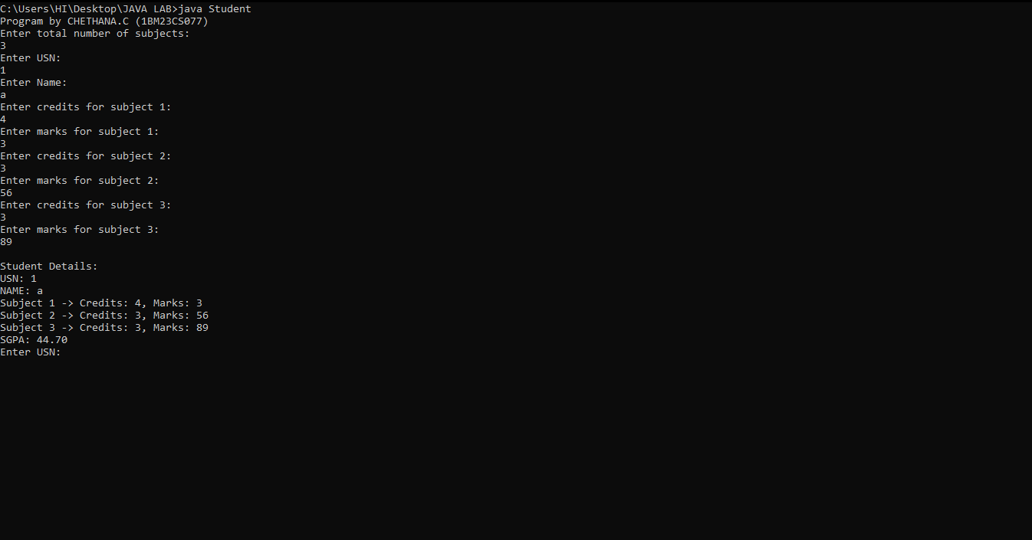

**Program 3**

Create a class Book which contains four members: name, author, price, num_pages. Include a constructor to set the values for the members. Include methods to set and get the details of the objects. Include a toString( ) method that could display the complete details of the book. Develop a  
Java program to create n book objects.

Algorithm:

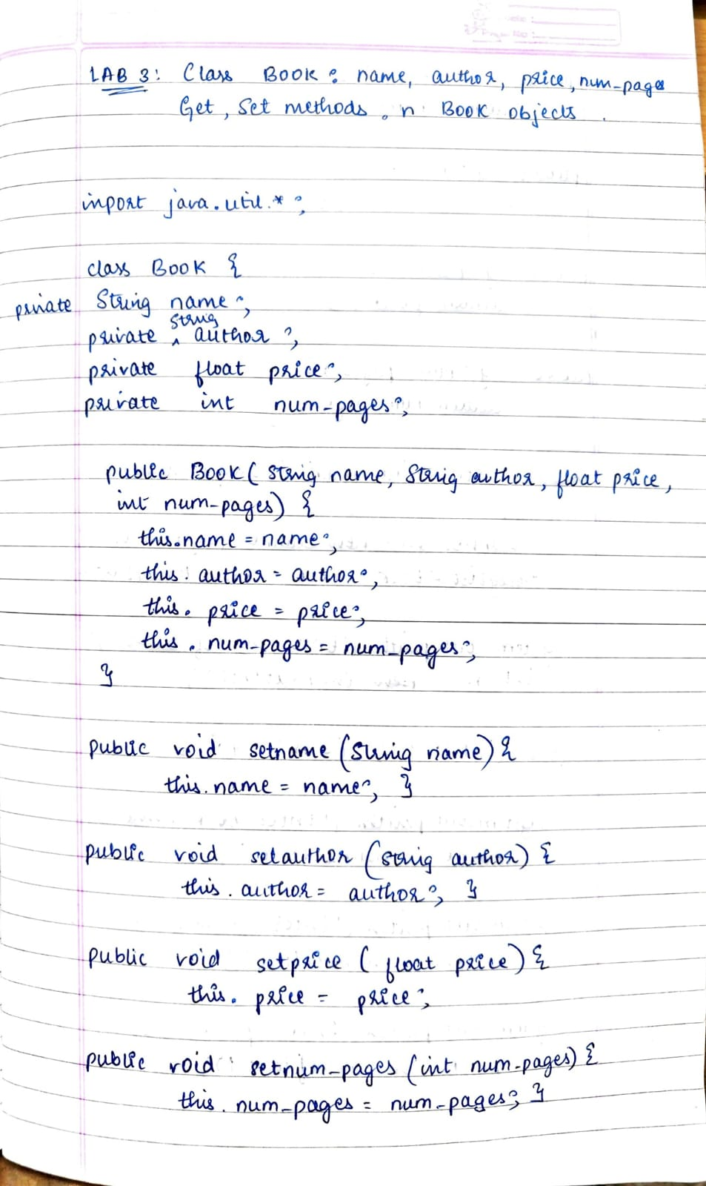

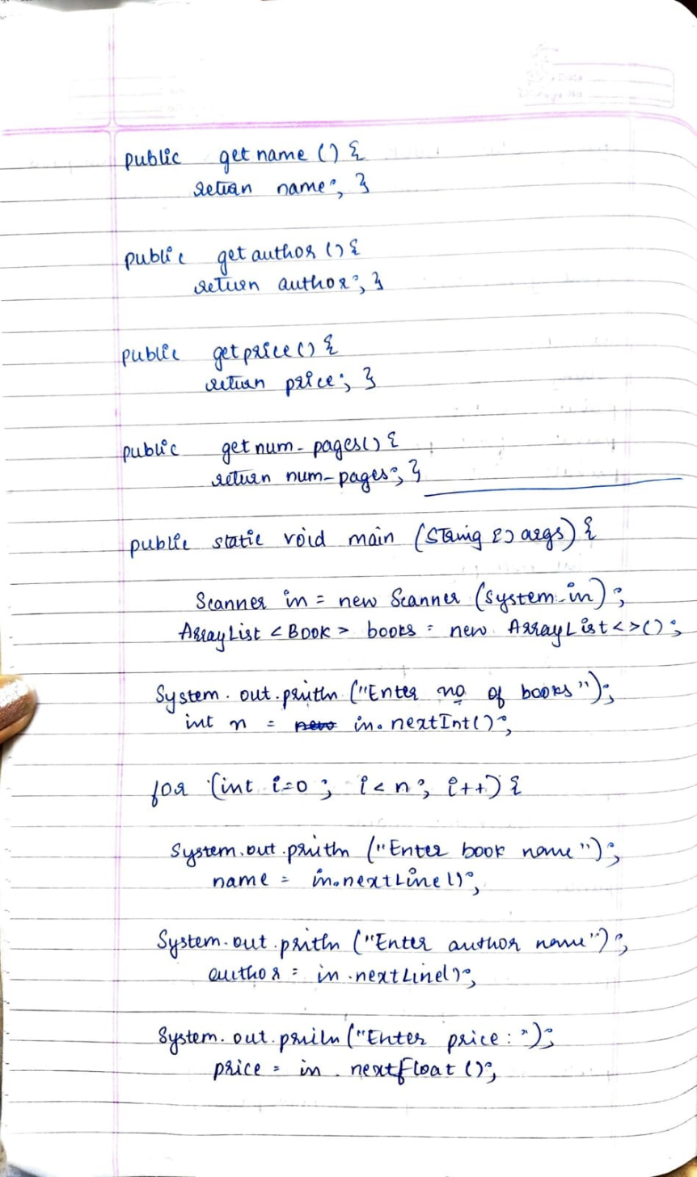

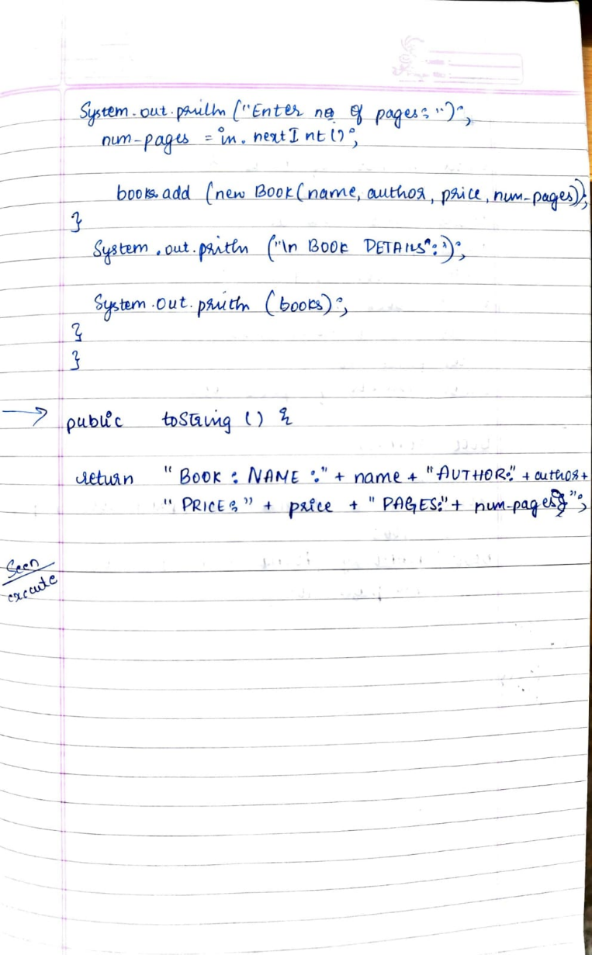

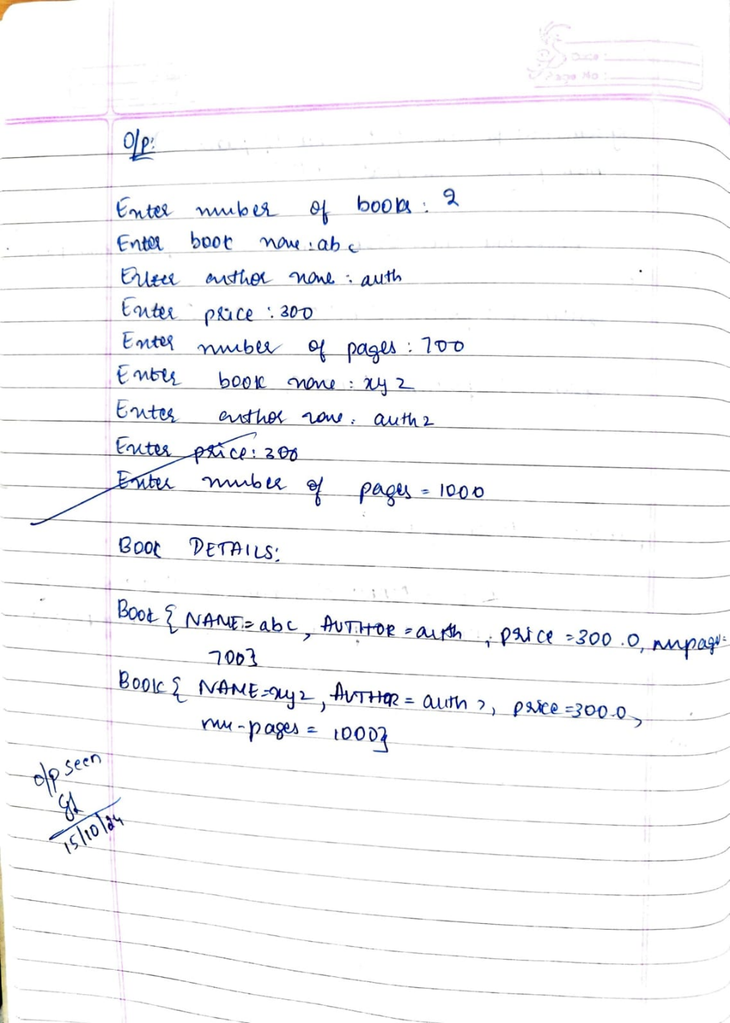

Code:

import java.util.*;

class Book {

private String name;

private String author;

private double price;

private int numPages;

public Book(String name, String author, double price, int numPages) {

this.name = name;

this.author = author;

this.price = price;

this.numPages = numPages;

}

public void setName(String name) {

this.name = name;

}

public void setAuthor(String author) {

this.author = author;

}

public void setPrice(double price) {

this.price = price;

}

public void setNumPages(int numPages) {

this.numPages = numPages;

}

public String getName() {

return name;

}

public String getAuthor() {

return author;

}

public double getPrice() {

return price;

}

public int getNumPages() {

return numPages;

}

public String toString() {

return "Book{" +

"name='" + name + '\'' +

", author='" + author + '\'' +

", price=" + price +

", numPages=" + numPages +

'}';

}

public static void main(String[] args) {

Scanner scanner = new Scanner(System.in);

ArrayList<Book> books = new ArrayList<>();

System.out.print("Enter the number of books: ");

int n = scanner.nextInt();

scanner.nextLine(); // Consume the newline character left by nextInt()

for (int i = 0; i < n; i++) {

System.out.print("Enter book name: ");

String name = scanner.nextLine();

System.out.print("Enter author name: ");

String author = scanner.nextLine();

System.out.print("Enter price: ");

double price = scanner.nextDouble();

System.out.print("Enter number of pages: ");

int numPages = scanner.nextInt();

scanner.nextLine(); // Consume the newline character

books.add(new Book(name, author, price, numPages));

}

System.out.println("\nBook Details:");

for (Book book : books) {

System.out.println(book); // This will automatically call toString()

}

}

}

Output:

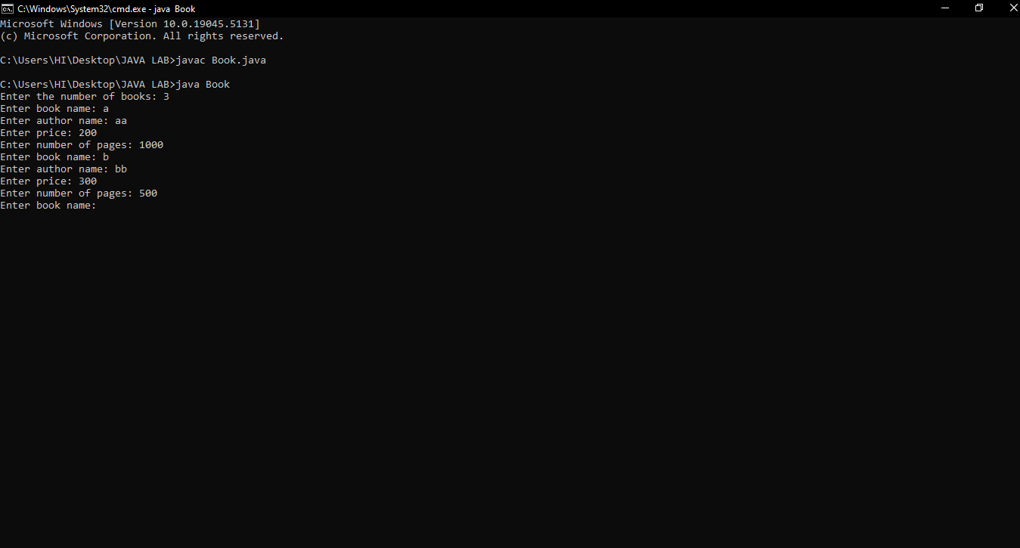

**Program 4**

Develop a Java program to create an abstract class named Shape that contains two integers and an empty method named printArea(). Provide three classes named Rectangle, Triangle and Circle such that each one of the classes extends the class Shape. Each one of the classes contain only the method printArea() that prints the area of the given shape.

Algorithm:

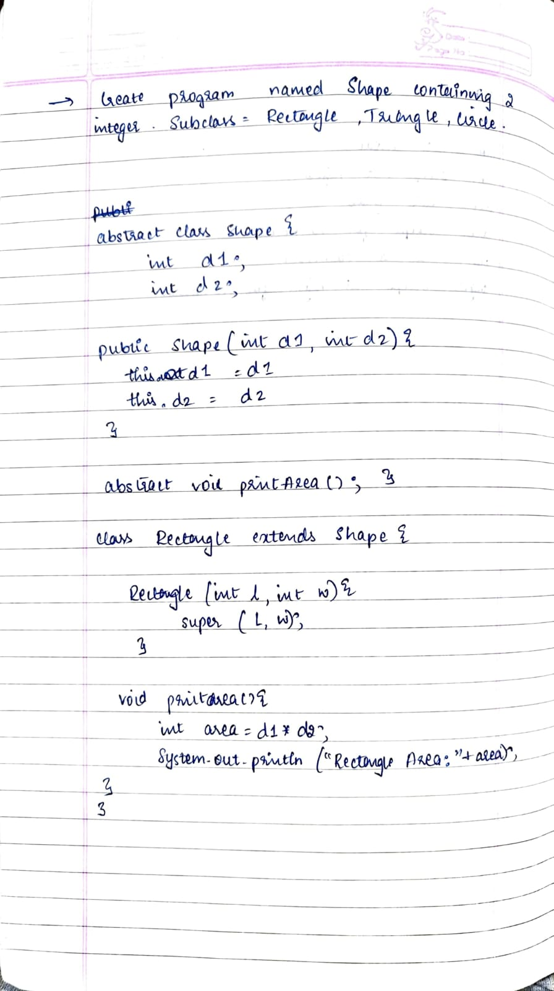

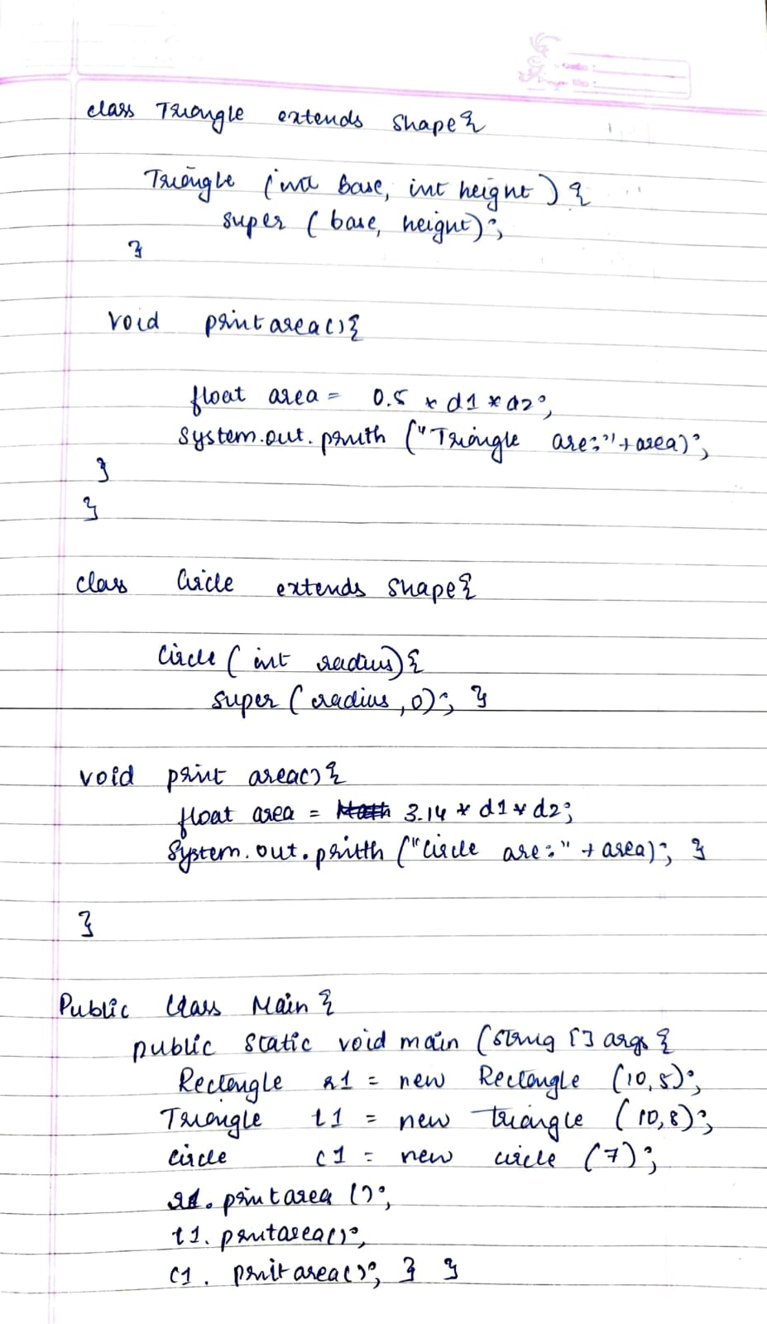

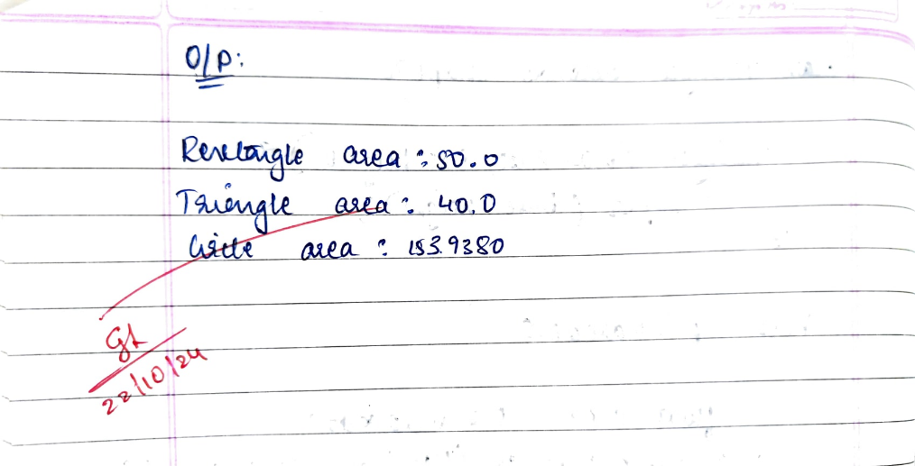

Code:

abstract class Shape {

int d1, d2;

public Shape(int d1, int d2) {

this.d1 = d1;

this.d2 = d2;

}

abstract void printArea();

}

class Rectangle extends Shape {

public Rectangle(int length, int width) {

super(length, width);

}

void printArea() {

int area = d1 * d2;

System.out.println("Rectangle Area: " + area);

}

}

class Triangle extends Shape {

public Triangle(int base, int height) {

super(base, height);

}

void printArea() {

float area = 0.5f * d1 * d2;

System.out.println("Triangle Area: " + area);

}

}

class Circle extends Shape {

public Circle(int radius) {

super(radius, 0);

}

void printArea() {

float area = (float) Math.PI * d1 * d1;

System.out.println("Circle Area: " + area);

}

}

public class AbstractShape {

public static void main(String[] args) {

System.out.println("CHETHANA.C(1BM23CS077)");

Rectangle r1 = new Rectangle(10, 5);

Triangle t1 = new Triangle(10, 8);

Circle c1 = new Circle(7);

r1.printArea();

t1.printArea();

c1.printArea();

}

}

Output:

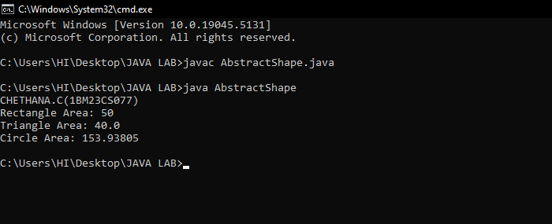

**Program 5**

Develop a Java program to create a class Bank that maintains two kinds of account for its customers, one called savings account and the other current account. The savings account provides compound interest and withdrawal facilities but no cheque book facility. The current account provides cheque book facility but no interest. Current account holders should also maintain a minimum balance and if the balance falls below this level, a service charge is imposed.

Create a class Account that stores customer name, account number and type of account. From this derive the classes Cur-acct and Sav-acct to make them more specific to their requirements. Include the necessary methods in order to achieve the following tasks:

a) Accept deposit from customer and update the balance.

b) Display the balance.

c) Compute and deposit interest

d) Permit withdrawal and update the balance

Check for the minimum balance, impose penalty if necessary and update the balance.

Algorithm:

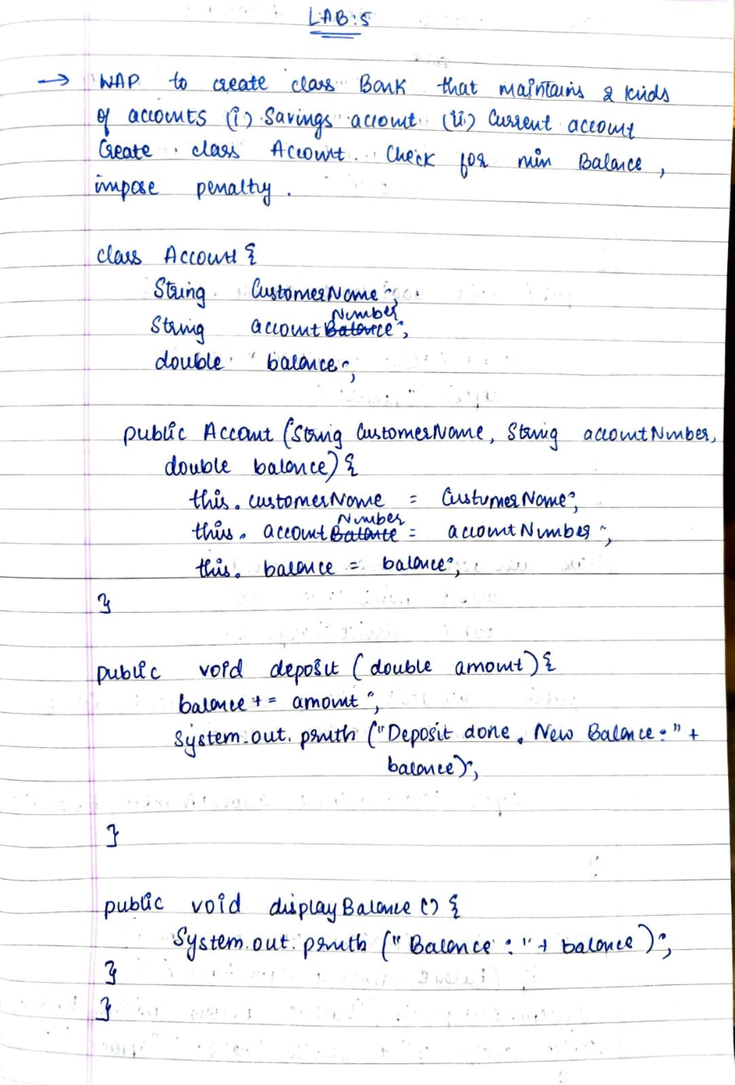

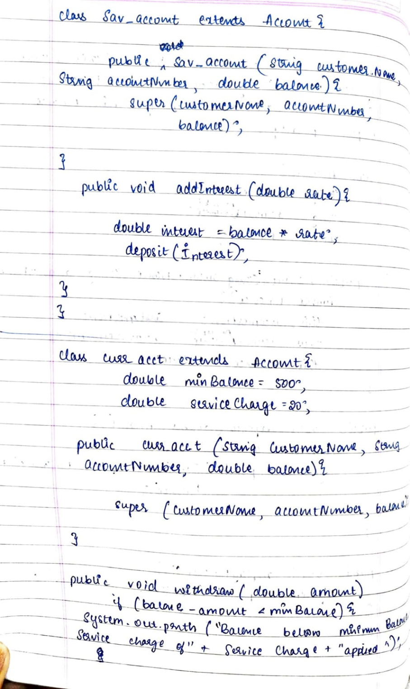

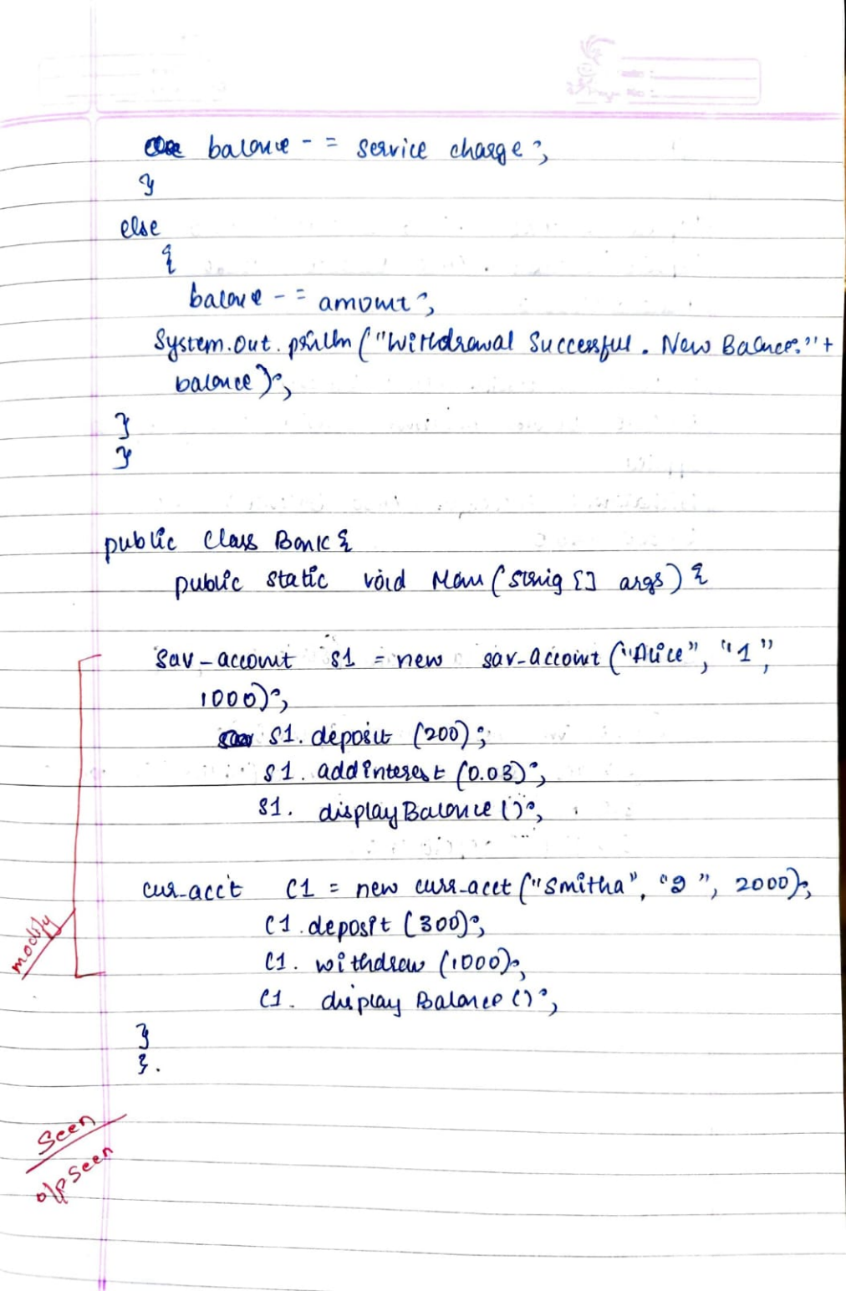

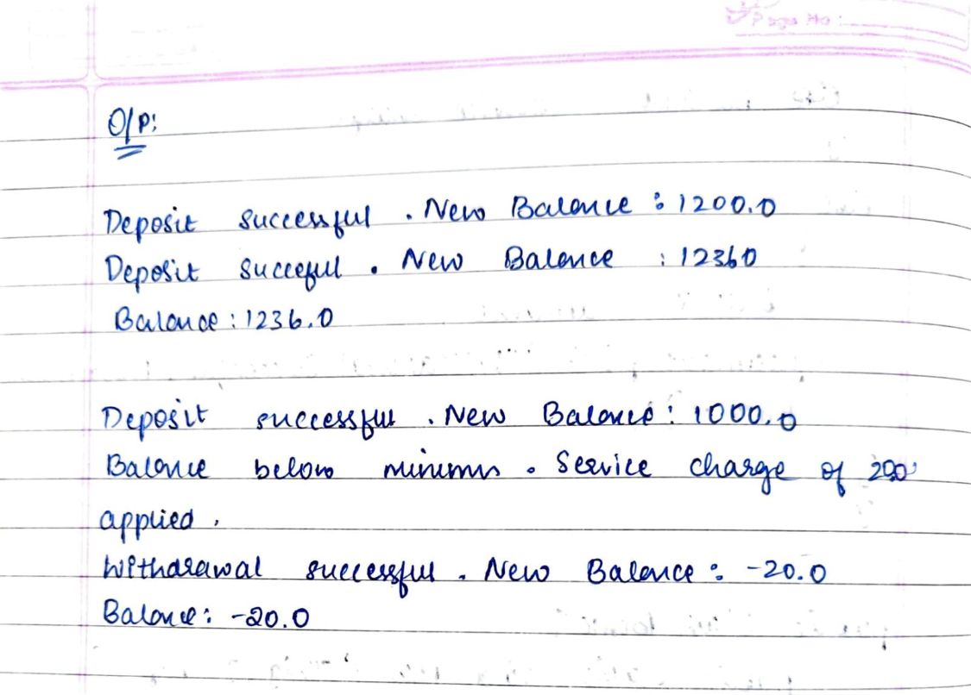

Code:

class Account {

String customerName;

String accountNumber;

double balance;

public Account(String customerName, String accountNumber, double balance) {

this.customerName = customerName;

this.accountNumber = accountNumber;

this.balance = balance;

}

public void deposit(double amount) {

balance += amount;

System.out.println("Deposit done. New Balance: " + balance);

}

public void displayBalance() {

System.out.println("Balance: " + balance);

}

}

class SavingsAccount extends Account {

public SavingsAccount(String customerName, String accountNumber, double balance) {

super(customerName, accountNumber, balance);

}

public void addInterest(double rate) {

double interest = balance * rate;

deposit(interest);

}

}

class CurrentAccount extends Account {

double minBalance = 500;

double serviceCharge = 20;

public CurrentAccount(String customerName, String accountNumber, double balance) {

super(customerName, accountNumber, balance);

}

public void withdraw(double amount) {

if (balance - amount < minBalance) {

System.out.println("Balance below minimum balance. Service charge of " + serviceCharge + " applied.");

balance -= serviceCharge;

} else {

balance -= amount;

System.out.println("Withdrawal successful. New Balance: " + balance);

}

}

}

public class Bank {

public static void main(String[] args) {

System.out.println("CHETHANA.C(1BM23CS077)");

SavingsAccount s1 = new SavingsAccount("Ayu", "1", 1000);

s1.deposit(200);

s1.addInterest(0.08);

s1.displayBalance();

CurrentAccount c1 = new CurrentAccount("Smith", "2", 2000);

c1.deposit(300);

c1.withdraw(1000);

c1.displayBalance();

}

}

Output:

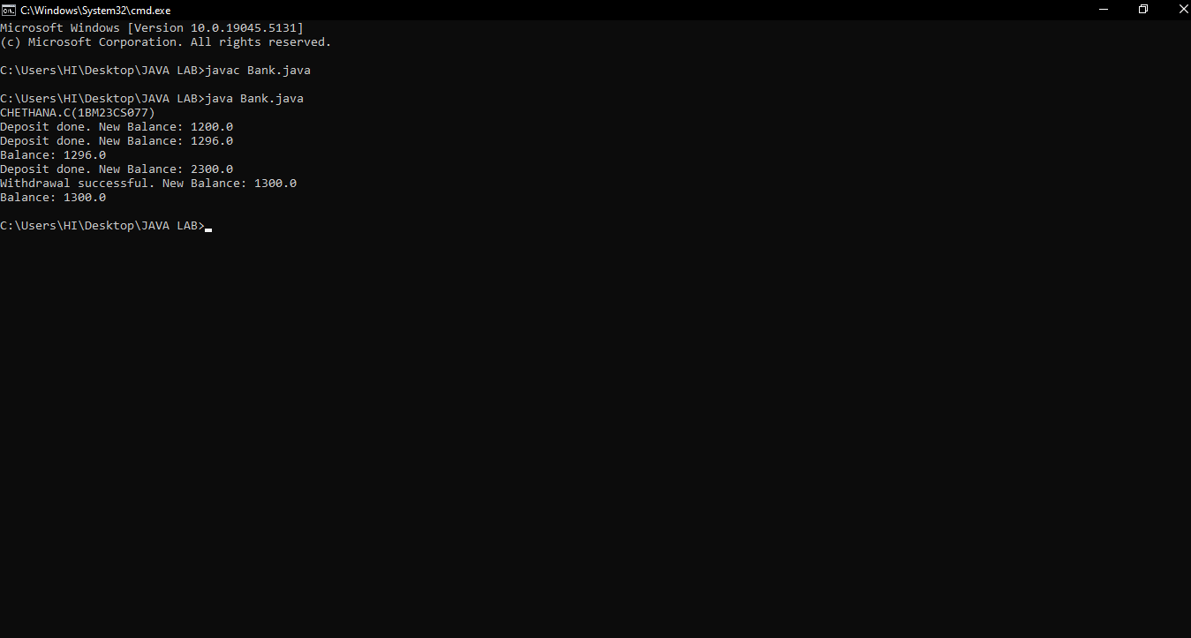

**Program 6**

Create a package CIE which has two classes- Student and Internals. The class Personal has members like usn, name, sem. The class internals has an array that stores the internal marks scored in five courses of the current semester of the student. Create another package SEE which has the class External which is a derived class of Student. This class has an array that stores the SEE marks scored in five courses of the current semester of the student. Import the two packages in a file that declares the final marks of n students in all five courses.

Algorithm:

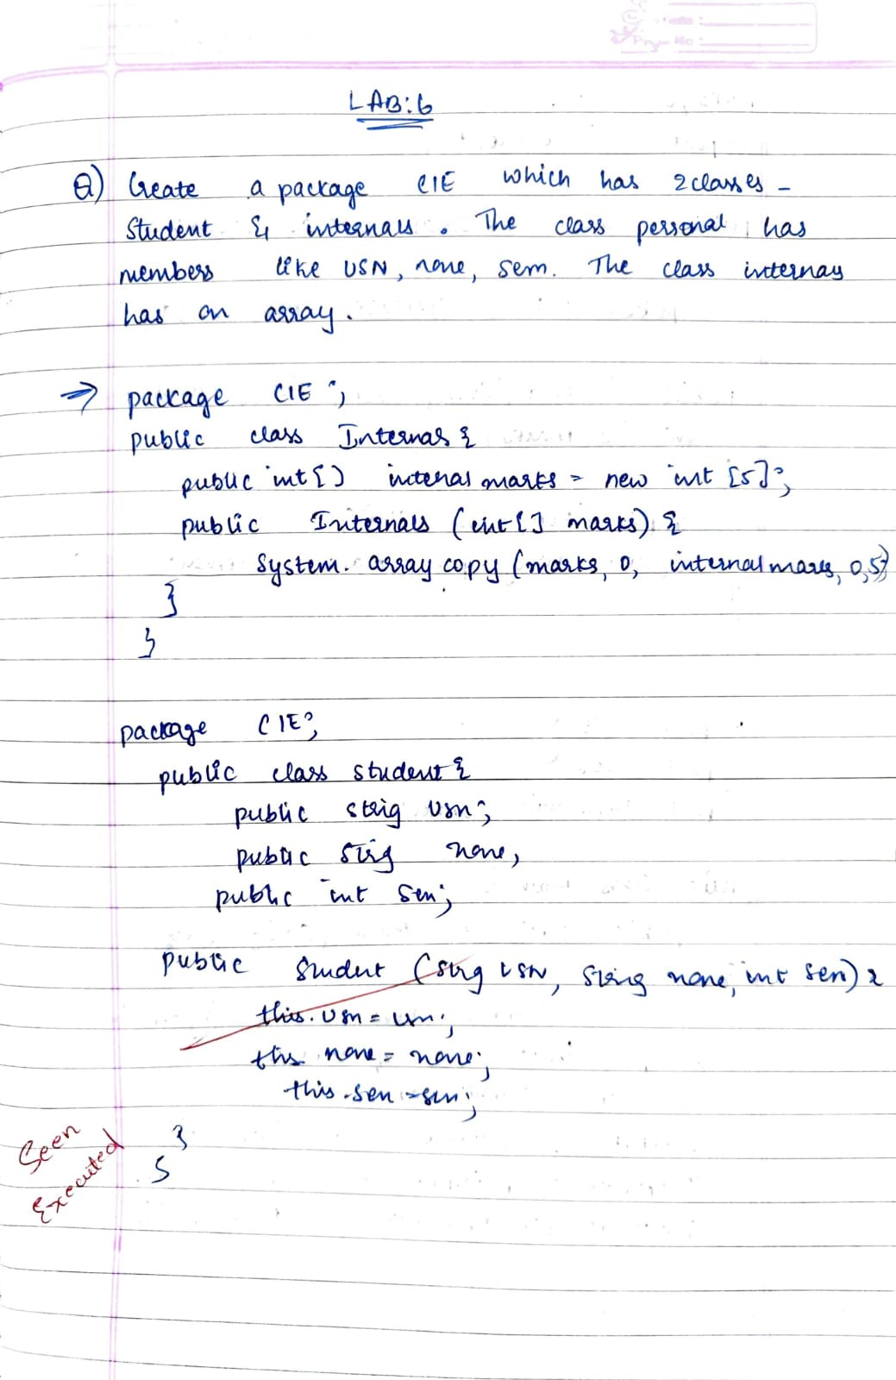

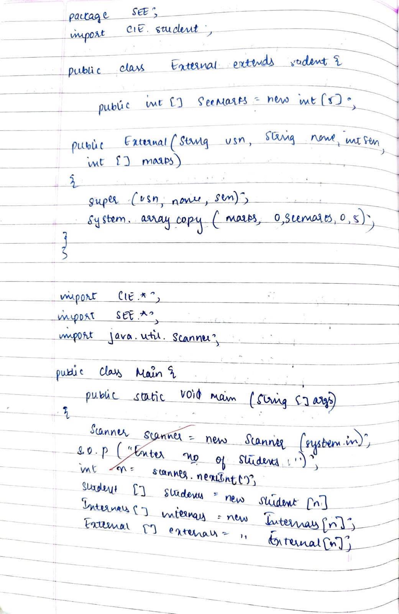

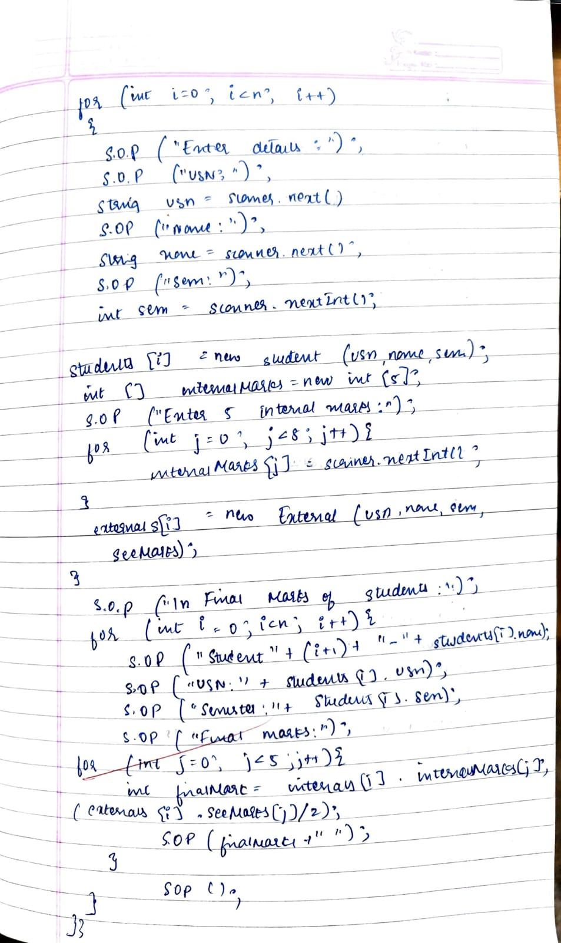

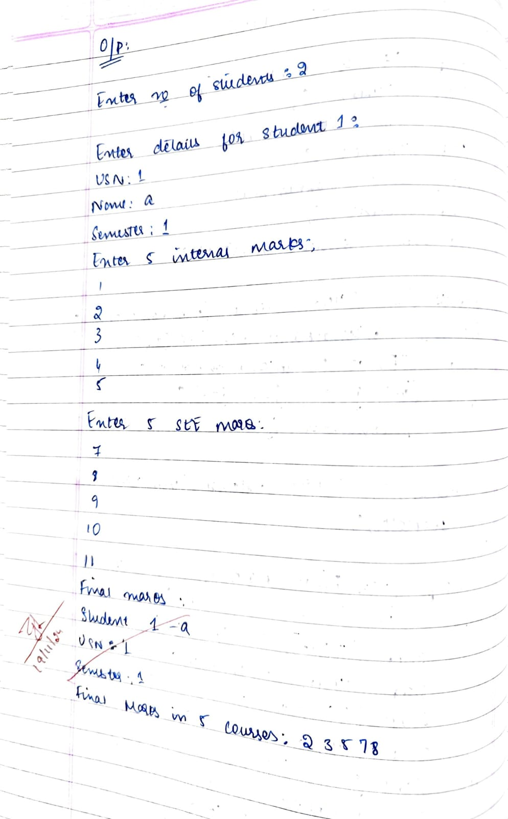

Code:

package CIE;

public class Internals {

int[] internalMarks;

public Internals(int[] marks) {

this.internalMarks = new int[marks.length];

System.arraycopy(marks, 0, internalMarks, 0, marks.length);

}

}

package CIE;

public class Student {

public String usn;

public String name;

public int sem;

public Student(String usn, String name, int sem) {

this.usn = usn;

this.name = name;

this.sem = sem;

}

}

package SEE;

import CIE.Student;

import CIE.Internals;

public class External extends Student {

public int[] externalMarks = new int[5];

public External(String usn, String name, int sem, int[] marks) {

super(usn, name, sem);

System.arraycopy(marks, 0, externalMarks, 0, marks.length);

}

public int calculateFinalMarks() {

int totalMarks = 0;

for (int i = 0; i < 5; i++) {

totalMarks += externalMarks[i];

}

return totalMarks / 2;

}

}

import java.util.Scanner;

import CIE.Student;

import CIE.Internals;

import SEE.External;

public class Main {

public static void main(String[] args) {

Scanner scanner = new Scanner(System.in);

System.out.print("Enter number of students: ");

int n = scanner.nextInt();

scanner.nextLine();

Student[] students = new Student[n];

Internals[] internals = new Internals[n];

External[] externals = new External[n];

for (int i = 0; i < n; i++) {

System.out.println("Enter details of student " + (i + 1) + ":");

System.out.print("USN: ");

String usn = scanner.nextLine();

System.out.print("Name: ");

String name = scanner.nextLine();

System.out.print("Semester: ");

int sem = scanner.nextInt();

scanner.nextLine();

students[i] = new Student(usn, name, sem);

System.out.print("Enter 5 internal marks: ");

int[] internalMarks = new int[5];

for (int j = 0; j < 5; j++) {

internalMarks[j] = scanner.nextInt();

}

scanner.nextLine();

internals[i] = new Internals(internalMarks);

System.out.print("Enter 5 external marks: ");

int[] externalMarks = new int[5];

for (int j = 0; j < 5; j++) {

externalMarks[j] = scanner.nextInt();

}

scanner.nextLine();

externals[i] = new External(usn, name, sem, externalMarks);

}

System.out.println("\nStudent Details:");

for (int i = 0; i < n; i++) {

System.out.println("Student " + (i + 1) + ":");

System.out.println("USN: " + students[i].usn);

System.out.println("Name: " + students[i].name);

System.out.println("Semester: " + students[i].sem);

System.out.print("Internal Marks: ");

for (int j = 0; j < 5; j++) {

System.out.print(internals[i].internalMarks[j] + " ");

}

System.out.println();

System.out.print("External Marks: ");

for (int j = 0; j < 5; j++) {

System.out.print(externals[i].externalMarks[j] + " ");

}

System.out.println();

System.out.println("Final Marks (External average): " + externals[i].calculateFinalMarks());

System.out.println();

}

}

}

Output:

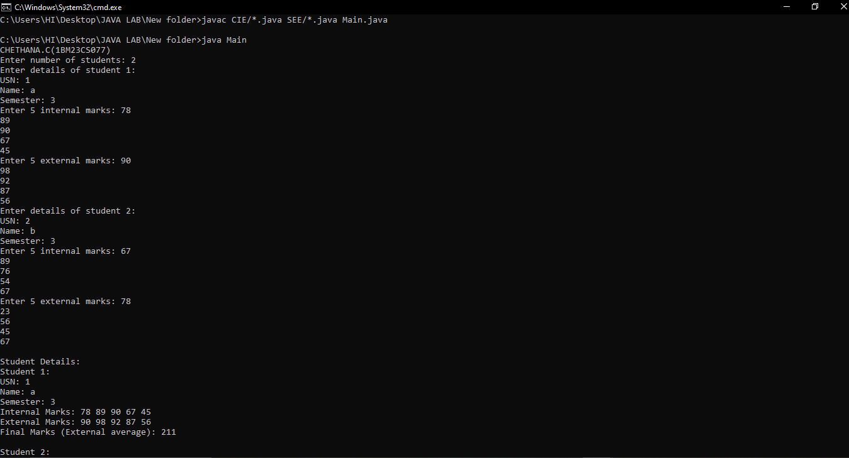

**Program 7**

We have created an interface named Polygon. It includes a default method getPerimeter() and an abstract method getArea ().

We can calculate the perimeter of all polygons in the same manner so we

implemented the body of get Perimeter() in Polygon.

Now, all polygons that implement Polygon can use getPerimeter () to calculate perimeter.

However, the rule for calculating the area is different for different polygons.

Hence, getArea() is included without implementation.

Any class that implements Polygon must provide an implementation of getArea ()

Algorithm:

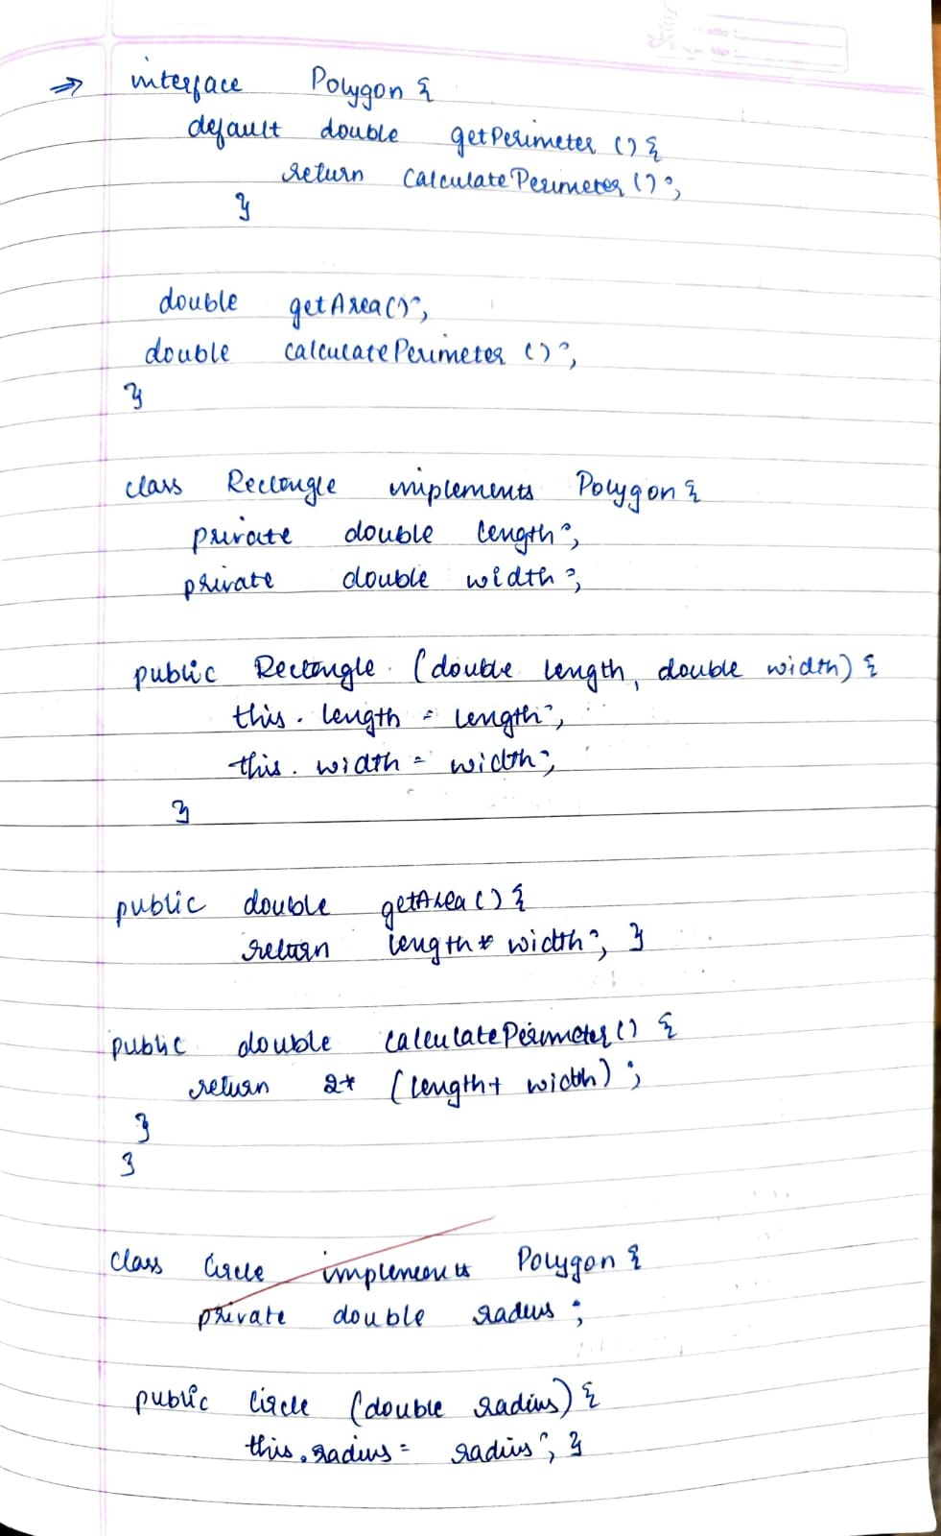

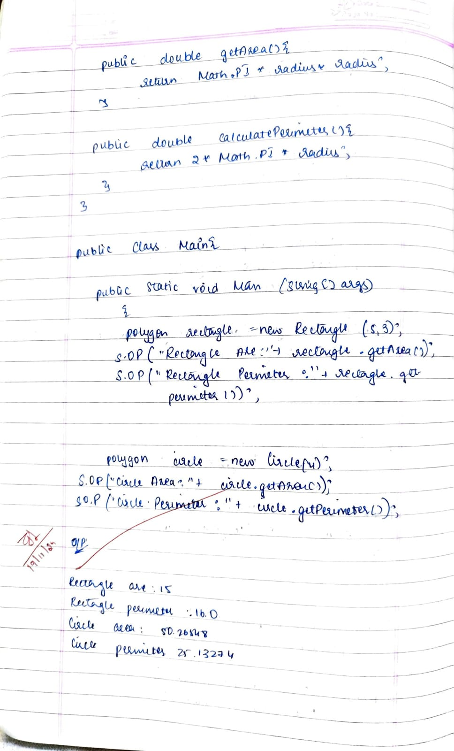

Code:

interface Polygon {

default double getPerimeter() {

return calculatePerimeter();

}

double getArea();

double calculatePerimeter();

}

class Rectangle implements Polygon {

private double length;

private double width;

public Rectangle(double length, double width) {

this.length = length;

this.width = width;

}

public double getArea() {

return length * width;

}

public double calculatePerimeter() {

return 2 * (length + width);

}

}

class Circle implements Polygon {

private double radius;

public Circle(double radius) {

this.radius = radius;

}

public double getArea() {

return Math.PI * radius * radius;

}

public double calculatePerimeter() {

return 2 * Math.PI * radius;

}

}

public class Main4 {

public static void main(String[] args) {

Polygon rectangle = new Rectangle(5, 3);

System.out.println("Rectangle Area: " + rectangle.getArea());

System.out.println("Rectangle Perimeter: " + rectangle.getPerimeter());

Polygon circle = new Circle(4);

System.out.println("Circle Area: " + circle.getArea());

System.out.println("Circle Perimeter: " + circle.getPerimeter());

System.out.println("Chethana c 1bm23cs077");

}

}

Output:

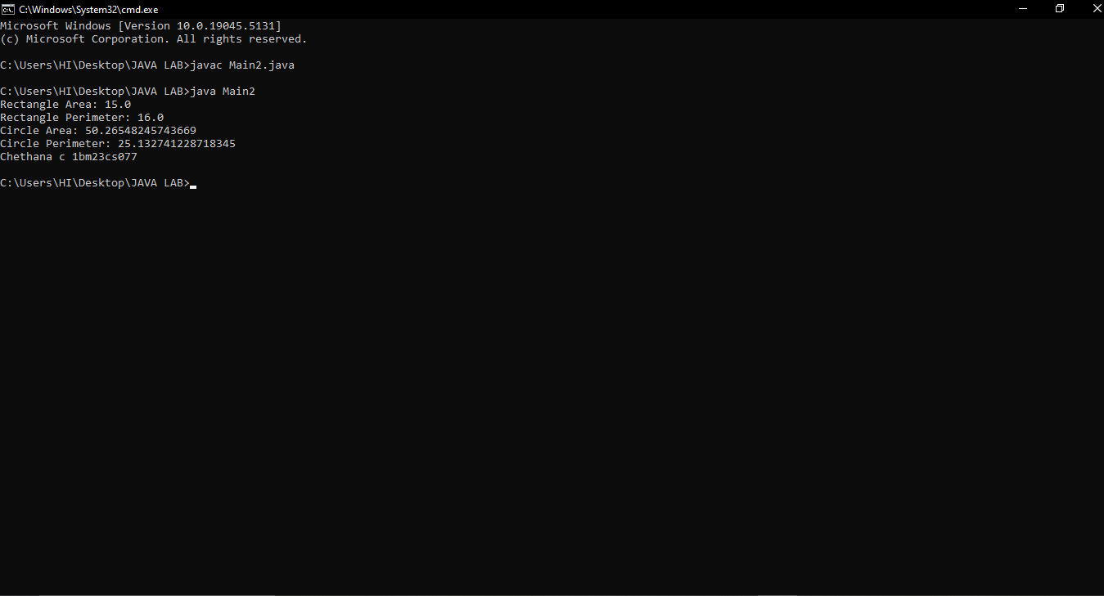

**Program 8**

Write a program that demonstrates handling of exceptions in inheritance tree. Create a base class called "Father" and derived class called "Son" which extends the base class. In Father class, implement a constructor which takes the age and throws the exception WrongAge() when the input age<0. In Son class, implement a constructor that uses both father and son's age and throws an exception if son's age is >=father's age.

Algorithm:

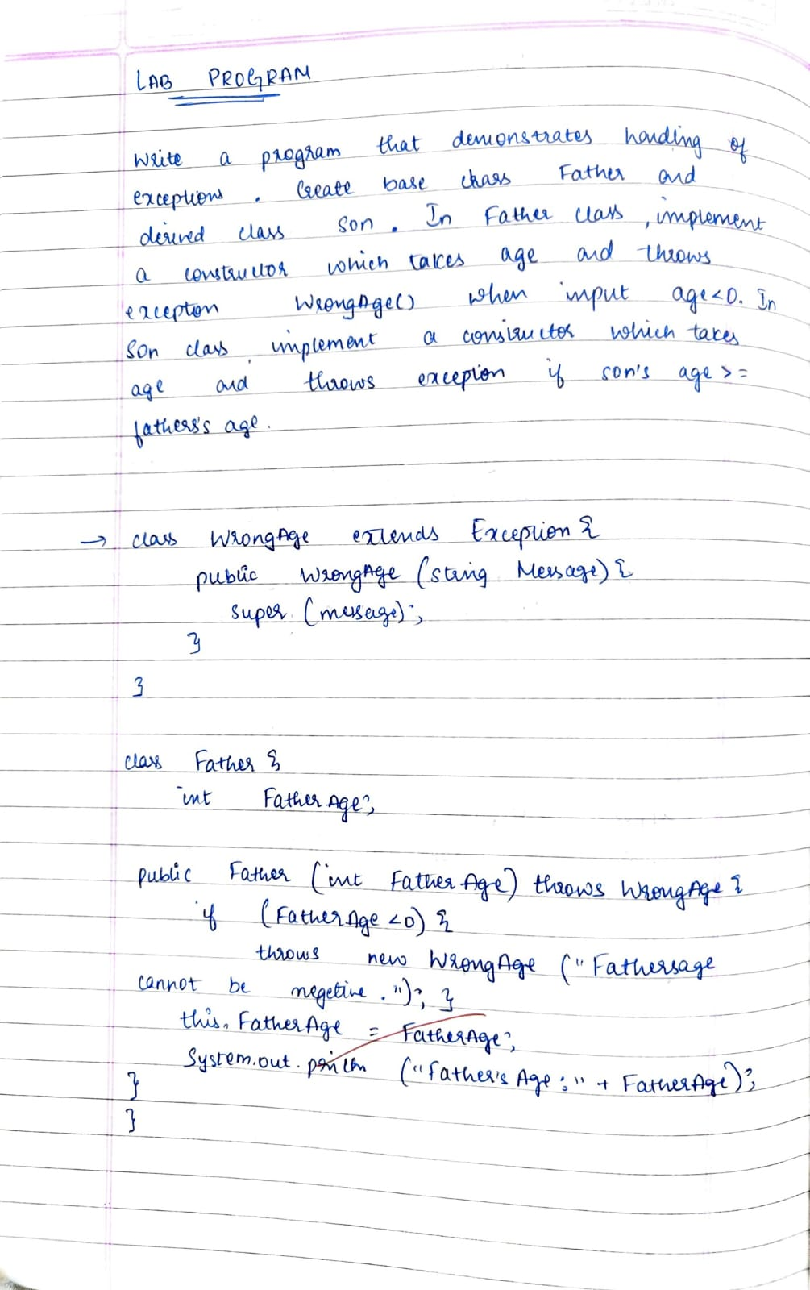

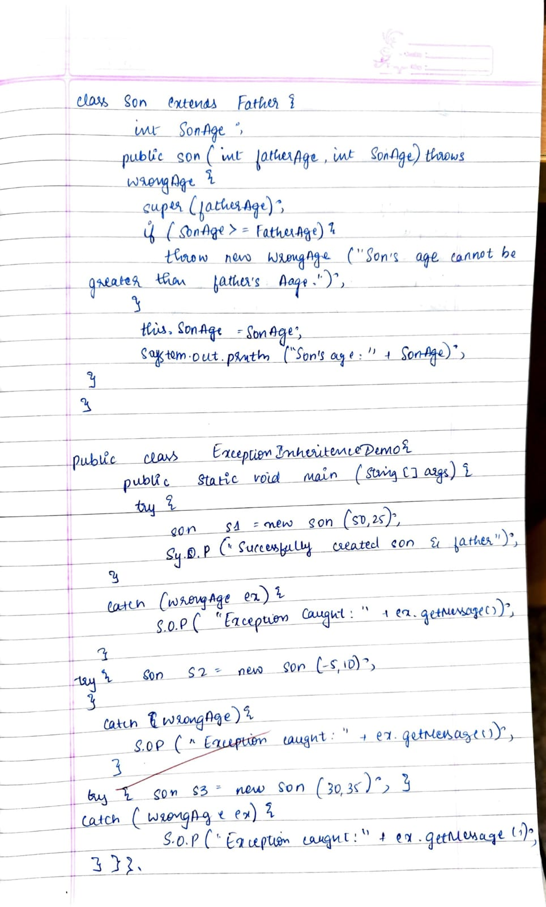

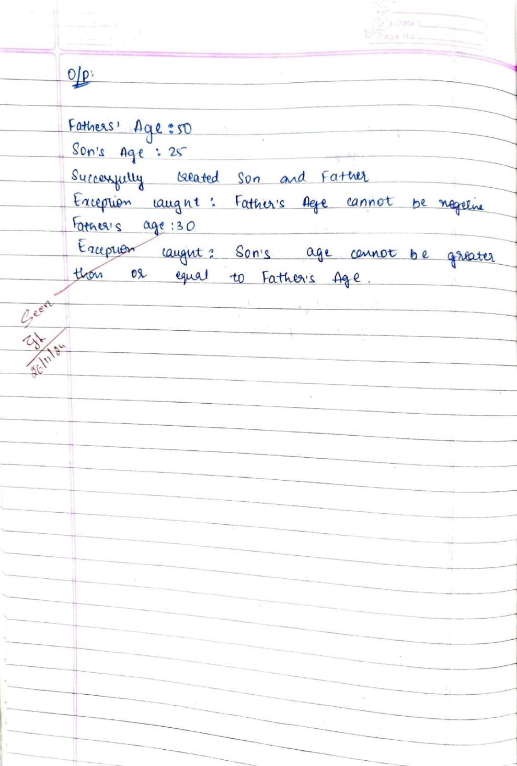

Code:

class WrongAge extends Exception {

public WrongAge(String message) {

super(message);

}

}

class Father {

int fatherAge;

public Father(int fatherAge) throws WrongAge {

if (fatherAge < 0) {

throw new WrongAge("Father's age cannot be negative.");

}

this.fatherAge = fatherAge;

System.out.println("Father's Age: " + fatherAge);

}

}

class Son extends Father {

int sonAge;

public Son(int fatherAge, int sonAge) throws WrongAge {

super(fatherAge);

if (sonAge > fatherAge) {

throw new WrongAge("Son's age cannot be greater than father's age.");

}

this.sonAge = sonAge;

System.out.println("Son's Age: " + sonAge);

}

}

public class ExceptionInheritanceDemo {

public static void main(String[] args) {

System.out.println("CHETHANA.C(1bm23cs077)");

try {

Son son1 = new Son(50, 25);

System.out.println("Successfully created son and father.");

} catch (WrongAge e) {

System.out.println("Exception caught: " + e.getMessage());

}

try {

Son son2 = new Son(-5, 10);

} catch (WrongAge e) {

System.out.println("Exception caught: " + e.getMessage());

}

try {

Son son3 = new Son(30, 35);

} catch (WrongAge e) {

System.out.println("Exception caught: " + e.getMessage());

}

}

}

Output:

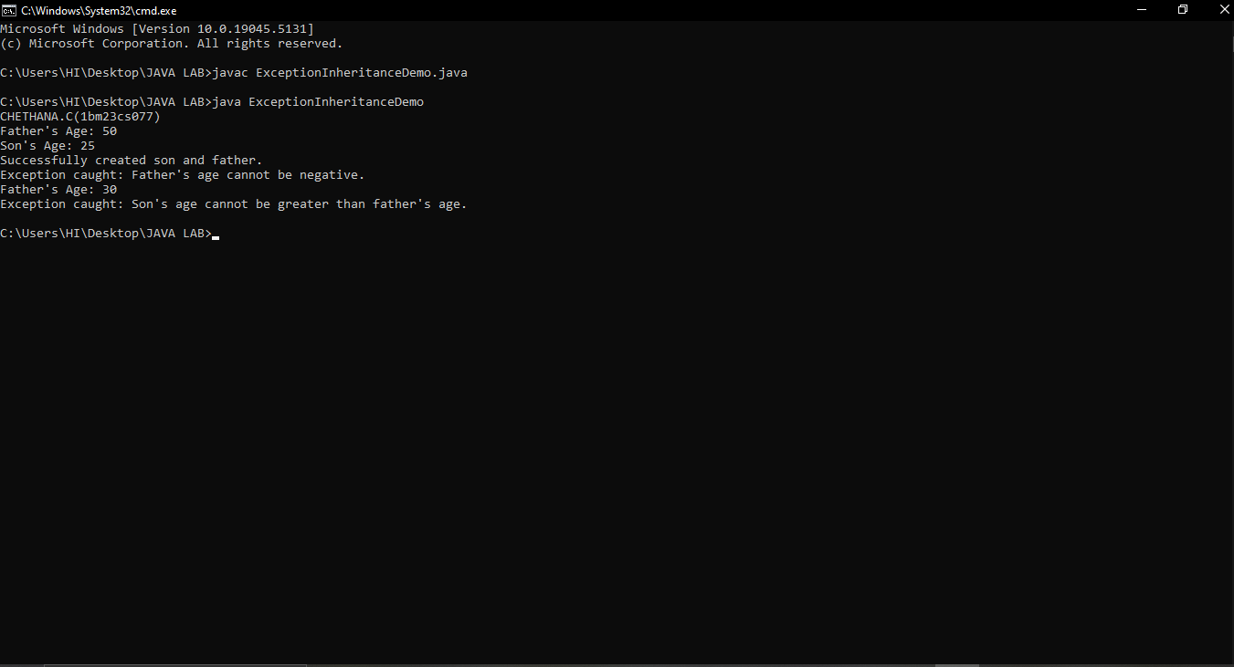

**Program 9**

Write a program which creates two threads, one thread displaying "BMS College of Engineering" once every ten seconds and another displaying "CSE" once every two seconds

Algorithm:

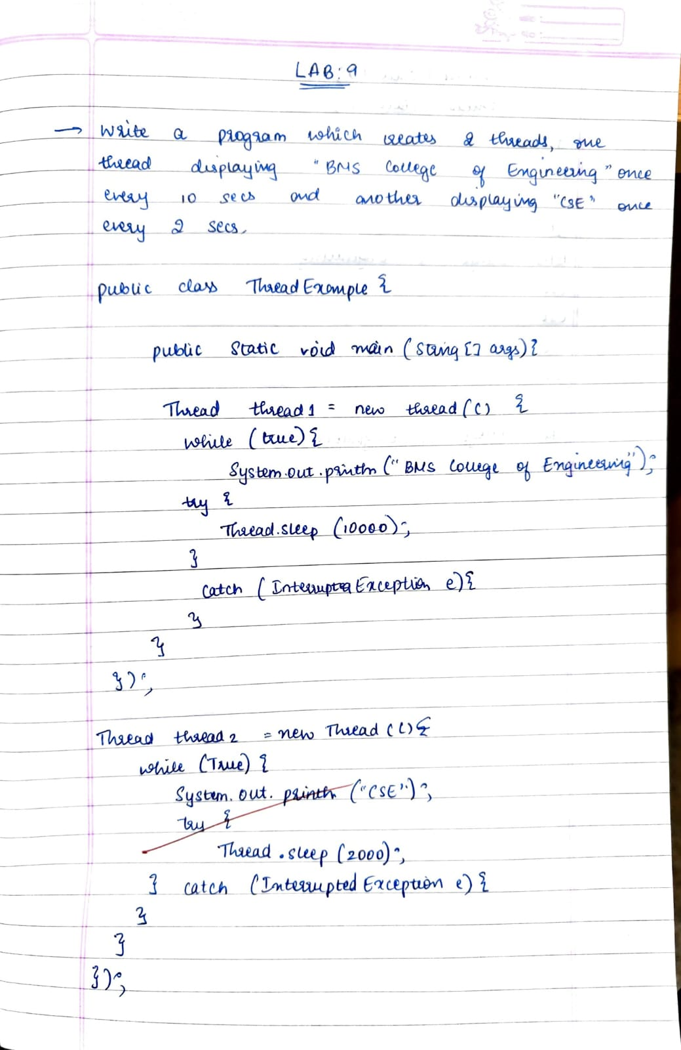

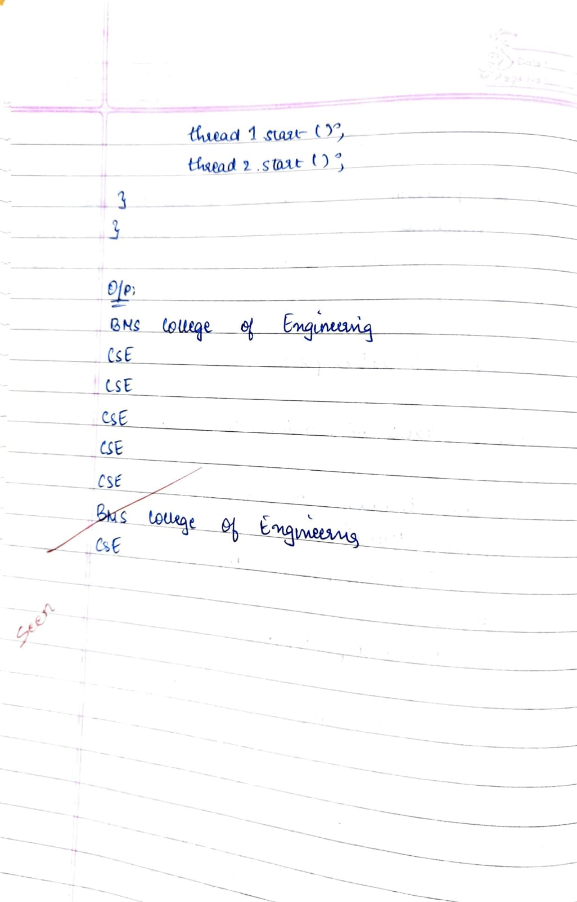

Code:

public class ThreadExample {

public static void main(String[] args) {

System.out.println("CHETHANA.C(1BM23CS077)");

Thread thread1 = new Thread(new Runnable() {

public void run() {

try {

while (true) {

System.out.println("BMS College of Engineering");

Thread.sleep(10000);

}

} catch (InterruptedException e) {

System.out.println(e);

}

}

});

Thread thread2 = new Thread(new Runnable() {

public void run() {

try {

while (true) {

System.out.println("CSE");

Thread.sleep(2000);

}

} catch (InterruptedException e) {

System.out.println(e);

}

}

});

thread1.start();

thread2.start();

}

}

Output:

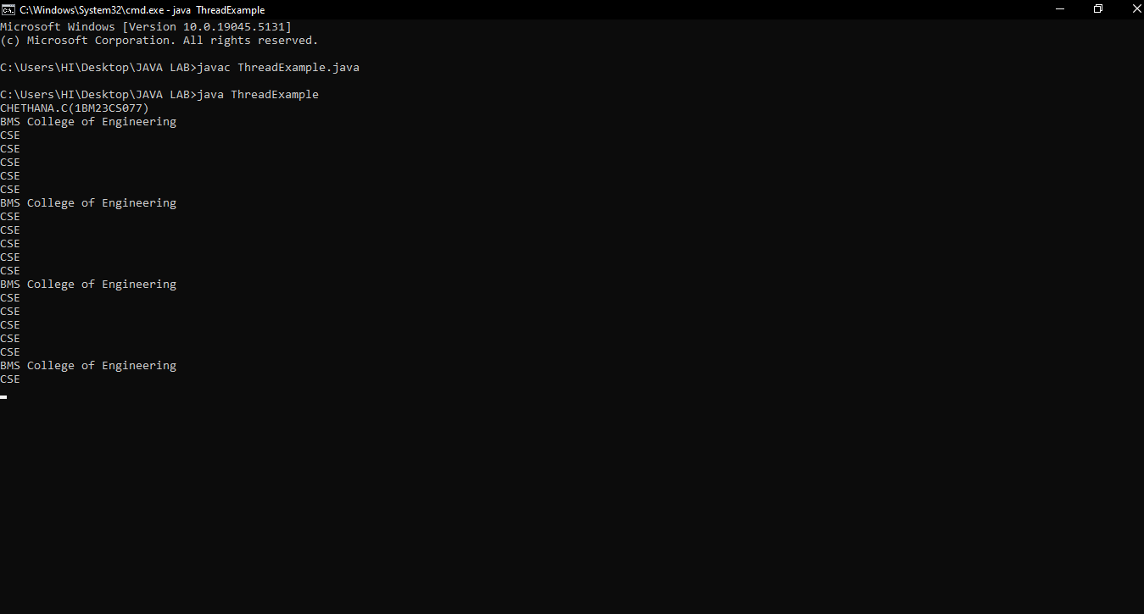

**Program 10**

Write a program that creates a user interface to perform integer divisions. The user enters two numbers in the text fields, Num1 and Num2. The division of Num1 and Num2 is displayed in the Result field when the Divide button is clicked. If Num1 or Num2 were not an integer, the program would throw a NumberFormatException. If Num2 were Zero, the program would throw an Arithmetic Exception Display the exception in a message dialog box

Algorithm:

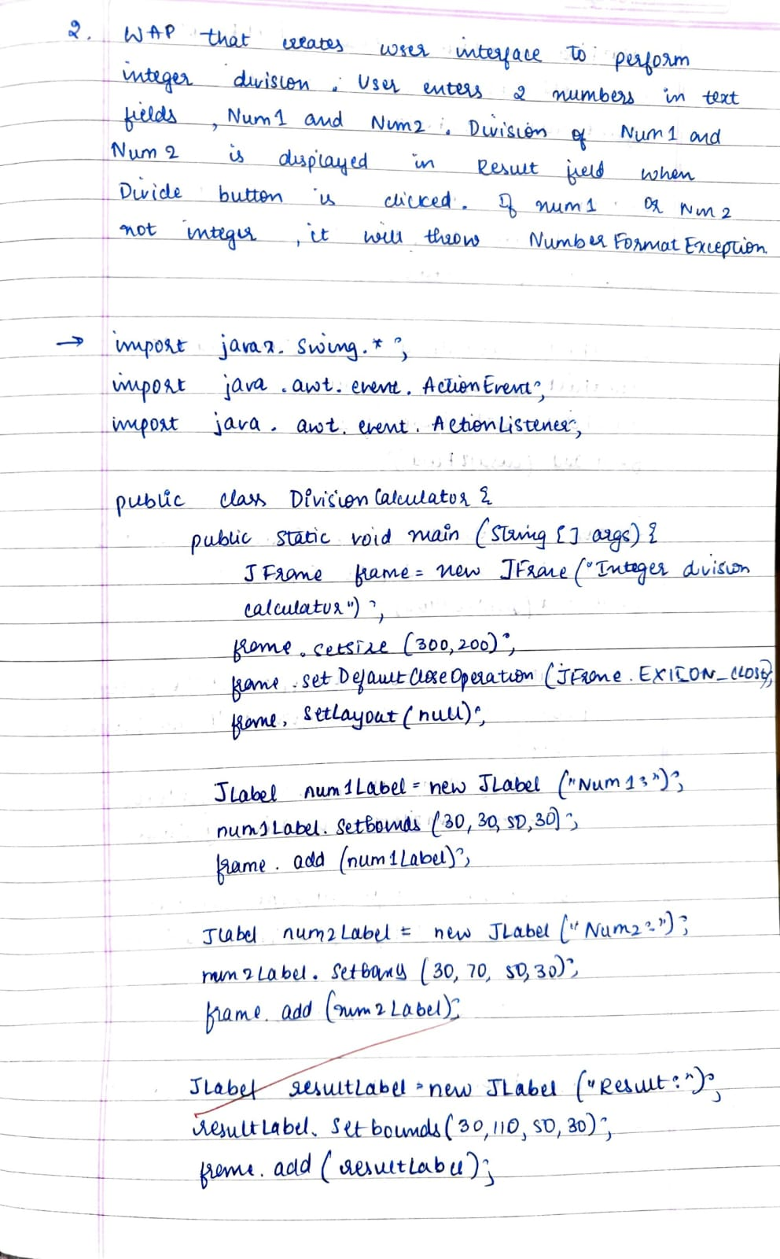

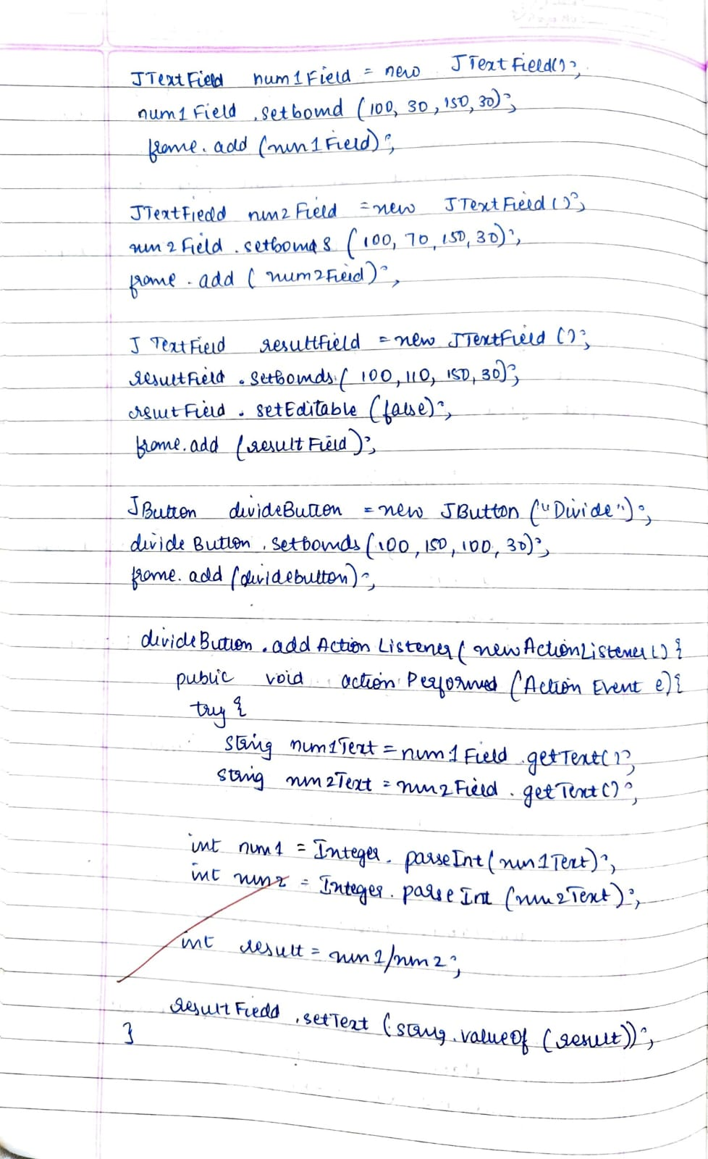

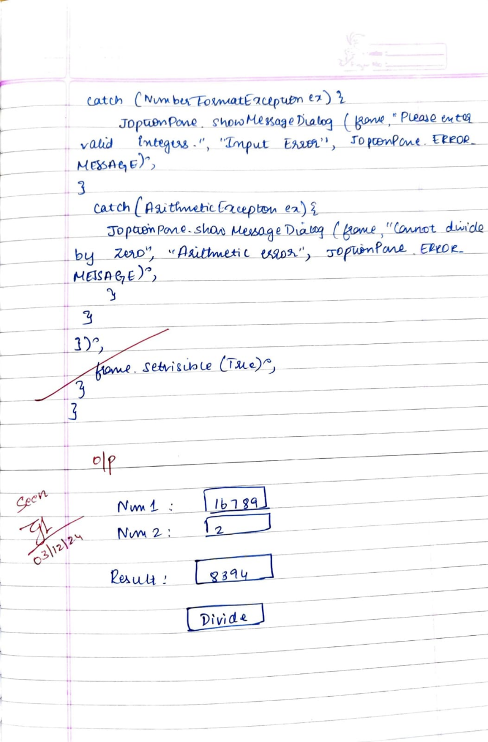

Code:

import javax.swing.*;

import java.awt.event.ActionEvent;

import java.awt.event.ActionListener;

public class DivisionCalculator {

public static void main(String[] args) {

JFrame frame = new JFrame("Integer Division Calculator");

frame.setSize(300, 200);

frame.setDefaultCloseOperation(JFrame.EXIT_ON_CLOSE);

frame.setLayout(null);

JLabel num1Label = new JLabel("Num 1");

num1Label.setBounds(30, 30, 50, 30);

frame.add(num1Label);

JLabel num2Label = new JLabel("Num 2");

num2Label.setBounds(30, 70, 50, 30);

frame.add(num2Label);

JLabel resultLabel = new JLabel("Result");

resultLabel.setBounds(30, 110, 50, 30);

frame.add(resultLabel);

JTextField num1Field = new JTextField();

num1Field.setBounds(100, 30, 150, 30);

frame.add(num1Field);

JTextField num2Field = new JTextField();

num2Field.setBounds(100, 70, 150, 30);

frame.add(num2Field);

JTextField resultField = new JTextField();

resultField.setBounds(100, 110, 150, 30);

resultField.setEditable(false);

frame.add(resultField);

JButton divideButton = new JButton("Divide");

divideButton.setBounds(100, 150, 100, 30);

frame.add(divideButton);

divideButton.addActionListener(new ActionListener() {

public void actionPerformed(ActionEvent e) {

try {

String num1Text = num1Field.getText();

String num2Text = num2Field.getText();

int num1 = Integer.parseInt(num1Text);

int num2 = Integer.parseInt(num2Text);

int result = num1 / num2;

resultField.setText(String.valueOf(result));

} catch (NumberFormatException ex) {

JOptionPane.showMessageDialog(frame, "Please enter valid integers", "Input Error", JOptionPane.ERROR_MESSAGE);

} catch (ArithmeticException ex) {

JOptionPane.showMessageDialog(frame, "Cannot divide by zero", "Arithmetic Error", JOptionPane.ERROR_MESSAGE);

}

}

});

frame.setVisible(true);

}

}

Output:

